A TECHNICAL REPORT
ON
INTEL XDK INTERNET OF THINGS

Submitted in partial fulfillment of the requirement
for the award of the degree

BACHELOR OF TECHNOLOGY
IN
COMPUTER SCIENCE & ENGINEERING
BY
K.LOKESHWAR REDDY | 11141A0542

Under the guidance of
Mr. T. MADHU (Ph.D.) M.Tech
Associate Professor


department of COMPUTER SCIENCE & engineering
SWAMI RamanandaTirtha
INSTITUTE OF SCIENCE AND TECHNOLOGY
Approved by A.I.C.T.E, Affiliated to J.N.T.U, Hyderabad
Nalgonda-508 001
2014-2015
SWAMI RAMANANDA TIRTHA
Ph.No : (08682) 244122, 221610
Fax : 08682-231076, 221637
E-mail : srtistnalgonda@rediffmail.com
Website : www.srtist.ac.in
INSTITUTE OF SCIENCE & TECHNOLOGY
Ramananda Nagar, Post : SLBC., Nalgonda – 508004. (T.S.)
Approved by AICTE, New Delhi, Affiliated to J.N.T.U., Hyderabad.

CERTIFICATE

This is to certify that K.LOKESHWAR REDDY bearing Roll No. 11141A0542 has submitted a Technical report titled “INTEL XDK INTERNET OF THINGS “ in partial fulfillment of the requirements of the award of degree B.Tech in CSE by J.N.T.U, Hyderabad. This is a bonafide work carried out by him during the academic Year 2014-15.

INTERNAL GUIDE  Mr. T. MADHU M.Tech, (Ph.D.).  Assoc. Prof. in CSE Dept. |  | HEAD OF THE DEPARTMENT,CSE  Mr. T. MADHU M.Tech, (Ph.D.).  SRTIST, NALGONDA.

EXTERNAL PRINCIPAL

ACKNOWLEDGEMENT

I express thanks and gratitude to Mr. T. Madhu, HOD of Computer Science Department SRTIST College for giving me the opportunity to undertake this report in this esteemed organization and for his guidance and valuable suggestions for the successful completion of this technical support.

I express my heartfelt gratitude to Mr. A. Praveen Kumar, for his encouraging support and guidance in carrying out this technical report successfully.

K.LOKESHWAR REDDY
11141A0542

ABSTRACT

Intel’s html5 development tools are designed to help mobile web developers develop, test, and deploy apps to as many platforms as possible. Using web technologies such as html5, javascript*, and css3*, these tools will allow you to not only create and test mobile web apps, but also hybrid native apps.
The Objective of our Dissertation “HTML5” is to show what a HTML5 contained which is going to helpful to build Interactive Web applications, which is very difficult or not possible in previous version of HTML. The HTML5 work stems from the WHATWG (Web Hypertext Application Technology Working Group), and their focus is the development of HTML and APIs for web applications. The reason it came to life back in 2004, founded by people from Apple, Mozilla and Opera, was a worry about the direction W3C were taking with XHTML, and no focus on HTML or the real-life needs for web developers.

CONTENTS

- INTRODUCTION
- VERSIONS OF HTML5
- RULES OF HTML5
- NEW IN HTML5
- ADVANTAGES
- INTERNET OF THINGS
- Intel xdk
- develop
- emulate
- test
- DEBUG
- profile
- build
- CONCLUSION
- REFERANCES

INTRODUCTION
HTML5 is the next generation of HTML. The previous version of HTML, HTML 4.01, came in 1999. The web has changed a lot since then.HTML5 is still a work in progress. However, the major browsers support many of the new HTML5 elements and APIs. HTML5 is cooperation between the World Wide Web Consortium (W3C) and the Web Hypertext Application Technology Working Group (WHATWG). WHATWG was working with web forms and applications, and W3C was working with XHTML 2.0. In 2006, they decided to cooperate and create a new version of HTML.

The Objective of our Dissertation “HTML5” is to show what a HTML5 contained which is going to helpful to build Interactive Web applications, which is very difficult or not possible in previous version of HTML

VERSIONS IN HTML

HTML 1.0

- HTML 1.0 was the first release of HTML to the world.
- Not many people were involved in website creation at the time, and the language was very limiting.

HTML 2.0
- HTML 2.0 was developed by the Internet Engineering Task Force HTML Working Group in 1996.
- HTML 2.0 included everything from the original 1.0 specifications but added a few new features to the mix.

HTML 3.2
- HTML 3.2 became a W3C Recommendation 14 January, 1997. HTML 3.2 contained new features such as fonts, tables, applets, superscripts, subscripts and more, to the existing HTML 2.0 standard.
- One of the elements added to the HTML 3.2 standard, was the <font> tag. This tag introduced unnecessary complexity to the important task of separating HTML content (text) from its presentation (style). The <font> tag became deprecated in HTML 4.0.

HTML 4.0

- HTML 4.0 became a W3C Recommendation 18 December, 1997. A second release was issued on 24 April, 1998 with only some editorial corrections.
- (The most important feature of HTML 4.0 was the introduction of style sheets CSS).

HTML 4.01

- HTML 4.0 was a large evolution of the HTML standards, and the last iteration of classic HTML. HTML 4.0 was recommended by the W3C in December ’97 and became the official standard in April 1998

XHTML 1.0

- Close to the beginning of the 21st century the W3C issued their specifications of XHTML 1.0 as a recommendation. Since January 26, 2000 it stands as the joint-standard with HTML 4.01. XHTML marks a departure from the way new specs have worked — it is an entirely new branch of HTML

HTML5

- HTML5 is designed for the web, both now and in the future
- HTML5 introduce new features for embedding audio, video, graphics, client-side data storage and interactive documents.
- HTML5 also contains new elements like <header>, <footer> ,<time> , <section>,<figure> etc..

RULES IN HTML5

Some rules for HTML5 were established:

- New features should be based on HTML, CSS, DOM, and JavaScript
- Reduce the need for external plug-in (like Flash)
- Better error handling
- More markup to replace scripting
- HTML5 should be device independent
- The development process should be visible to the public
- New Structural Element

Tag | Description
<article> | Defines an article
<aside> | Defines content aside from the page content
<bdi> | Isolates a part of text that might be formatted in a different direction from other text outside it
<command> | Defines a command button that a user can invoke
<details> | Defines additional details that the user can view or hide
<summary> | Defines a visible heading for a <details> element
<figure> | Specifies self-contained content, like illustrations, diagrams, photos, code listings, etc.
<figcaption> | Defines a caption for a <figure> element
<footer> | Defines a footer for a document or section
<header> | Defines a header for a document or section
<hgroup> | Groups a set of <h1> to <h6> elements when a heading has multiple levels
<mark> | Defines marked/highlighted text
<meter> | Defines a scalar measurement within a known range (a gauge)
<nav> | Defines navigation links
<progress> | Represents the progress of a task
<ruby> | Defines a ruby annotation (for East Asian typography)
<rt> | Defines an explanation/pronunciation of characters (for East Asian typography)
<rp> | Defines what to show in browsers that do not support ruby annotations
<section> | Defines a section in a document
<time> | Defines a date/time
<wbr> | Defines a possible line-break
New Media Elements

Tag | Description
<audio> | Defines sound content
<video> | Defines a video or movie
<source> | Defines multiple media resources for <video> and <audio>
<embed> | Defines a container for an external application or interactive content (a plug-in)
<track> | Defines text tracks for <video> and <audio>

HTML5 Audio:
HTML5 provides a standard for playing audio files.

Audio on the Web
- Until now, there has not been a standard for playing audio files on a web page.
- Today, most audio files are played through a plug-in (like flash). However, different browsers may have different plug-ins.
- HTML5 defines a new element which specifies a standard way to embed an audio file on a web page: the <audio> element.

Audio Formats and Browser Support

Currently, there are 3 supported file formats for the <audio> element: MP3, Wav, and Ogg:

Browser | MP3 | Wav | Ogg
Internet Explorer 9 | YES | NO | NO
Firefox 4.0 | NO | YES | YES
Google Chrome 6 | YES | YES | YES
Apple Safari 5 | YES | YES | NO
Opera 10.6 | NO | YES | YES

HTML5 Audio Tags

Tag | Description
<audio> | Defines sound content
<source> | Defines multiple media resources for media elements, such as <video> and <audio>

HTML5 Video:
Many modern websites show videos. HTML5 provides a standard for showing them.

Video on the Web
- Until now, there has not been a standard for showing a video/movie on a web page.
- Today, most videos are shown through a plug-in (like flash). However, different browsers may have different plug-ins.
- HTML5 defines a new element which specifies a standard way to embed a video/movie on a web page: the <video> element.
- The control attribute adds video controls, like play, pause, and volume.
- It is also a good idea to always include width and height attributes. If height and width are set, the space required for the video is reserved when the page is loaded. However, without these attributes, the browser does not know the size of the video, and cannot reserve the appropriate space to it. The effect will be that the page layout will change during loading (while the video loads).
- You should also insert text content between the <video> and </video> tags for browsers that do not support the <video> element.
- The <video> element allows multiple <source> elements. <source> elements can link to different video files. The browser will use the first recognized format.

Video Formats and Browser Support

Currently, there are 3 supported video formats for the <video> element: MP4, WebM, and Ogg:

Browser | MP3 | Wav | Ogg
Internet Explorer 9 | YES | NO | NO
Firefox 4.0 | NO | YES | YES
Google Chrome 6 | YES | YES | YES
Apple Safari 5 | YES | NO | NO
Opera 10.6 | NO | YES | YES

- MP4 = MPEG 4 files with H264 video codec and AAC audio codec
- WebM = WebM files with VP8 video codec and Vorbis audio codec
- Ogg = Ogg files with Theora video codec and Vorbis audio codec

Tag | Description
<video> | Defines a video or movie
<source> | Defines multiple media resources for media elements, such as <video> and <audio>
<track> | Defines text tracks in mediaplayers

AUDIO & VIDEO APPLICATION:

<!DOCTYPE html>
<html>
<body>

<!-- Video Player -->

<table border="5" align="left">
<tr>
<td align="center">
<h1> <b>WelCome To Video Player</h1>
</td>
</tr>
<tr>
<td align="center">
<video width="500" height="400" controls="controls">
<!-- <source src="video/movie.mp4" type="video/mp4" />-->
<source src="video/movie.ogg" type="video/ogg" />
Your browser does not support the video tag.
</video>
</td>
</tr>
<tr>
<td>
<footer align="right">
<p><b>Posted by: Gaurav Thakar</p>

</footer>
</td>
</tr>

</table>

<!-- Audio Player -->
<table border="5" align="right">
<tr>
<td align="center">
<h1> <b>WelCome To Audio Player</h1>
</td>
</tr>
<tr>
<td align="center">
<audio controls="controls">
<source src="video/song.mp3" type="audio/mpeg" />
Your browser does not support the audio element.
</audio>
</td>
</tr>
<tr>
<td>
<footer align="right">
<p><b>Posted by: Nandini Vyas</p>

</footer>
</td>
</tr>

</table>
</body>
</html>

Output:

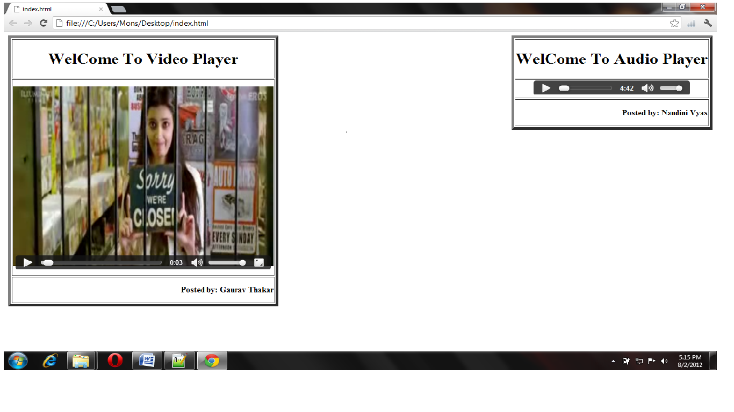
NEW IN HTML5

The first step is to set up a Google Docs spreadsheet for the project. Create a new sheet, give it a name (I named mine Power for this project, but you can name it as you wish), and set a title for the columns that we are going to use: Time, Interval, Power, and Energy (that will be calculated from the first two columns), as shown in the following screenshot:
We can also calculate the value of the energy using the other measurements. From theory, we know that over a given period of time, energy is power multiplied by time; that is, Energy = Power * Time. However, in our case, power is calculated at regular intervals, and we want to estimate the energy consumption for each of these intervals. In mathematical terms, this means we need to calculate the integral of power as a function of time. We don't have the exact function between time and power as we sample this function at regular time intervals, but we can estimate this integral using a method called the trapezoidal rule. It means that we basically estimate the integral of the function, which is the area below the power curve, by a trapeze. The energy in the C2 cell in the spreadsheet is then given by the formula: Energy= (PowerMeasurement + NextPowerMeasurement)*TimeInverval/2. Concretely, in Google Docs, you will need the formula, D2 = (B2 + B3)*C2/2. The Arduino Yún board will give you the power measurement, and the time interval is given by the value we set in the sketch. However, the time between two measurements can vary from measurement to measurement. This is due to the delay introduced by the network. To solve this issue, we will transmit the exact value along with the power measurement to get a much better estimate of the energy consumption. Then, it's time to build the sketch that we will use for the project. The goal of this sketch is basically to wait for commands that come from the network, to switch the relay on or off, and to send data to the Google Docs spreadsheet atregular intervals to keep track of the energy consumption these the new feature in corporated by google on release.
ADVANTAGES

1. Mutuality:

Due to usability purpose the web sites made by developers are highly interactive nowadays and for this developers need to include fluid animations, stream video, play music and Social Network sites like Face book and Twitter into the websites. Till now they have only the option to integrate it with the help of flash or silver light, Flex or JavaScript like tools.

2. Cleaner markup / Improved Code:

HTML 5 will enable web designers to use cleaner, neater code, we can remove most div tags and replace them with semantic HTML 5 elements.

3. Improved Semantics:

Now it is easy to see which parts of the page are headers, nav, footers, aside, etc as the tags are specific for these all and most importantly know what their meaning and purpose is in whole the format. By using HTML5 elements we can increase the semantic value of the web page as the codes are very standardized.

4. Elegant forms:

HTML5 enables designer to use more fancier forms. Even it makes form validation native to HTML, User interface enhancements and reduced need for JavaScript (only needed in browsers that don’t support form types). There will be different type of text inputs, search and different fields for different purpose.

5. Consistency:

As websites adopt the new HTML5 elements we will see more greater consistency in terms of the HTML used to code a web page on one site compared to another. This will make it easier for designers and developers to immediately understand how a web page is structured.

6. Improved Accessibility:

Different technologies can elaborate on the features with the help of HTML5, as they can immediately make more detailed understanding of the structure of a page by take a look at HTML5 elements it has.

7. Fulfill the need of Web application:

Many new features and standards have emerged as part of HTML 5. Once you detect the available features in today’s browsers, you can take advantage of those features in your application. Main focus of HTML5 is to make easier application with easy front-ends, drag and drop tools, discussion boards, wikis and other useful elements.

INTEL XDK

Intel’s HTML5 development tools are designed to help mobile web developers develop, test, and deploy apps to as many platforms as possible. using web technologies such as HTML5, JAVASCRIPT*, AND CSS3*, these tools will allow you to not only create and test mobile web apps, but also hybrid native apps.
the purpose of this document is to demonstrate to new users how to create a native hybrid application from scratch. it will outline how to get the INTEL® XDK, how to code a simple native hybrid application, how to test it on device, and finally how to use intel’s app dev center to build an application binary.

CREATE AN APP
The easiest way to get started is to create an app immediately. INTEL® makes things easy by providing a direct path to creating an application, getting the tools, and getting to work. using the google chrome browser, brand new users can get right into the tools straight from the INTEL® HTML5 development environment home page
at: http://html5dev-software.intel.com
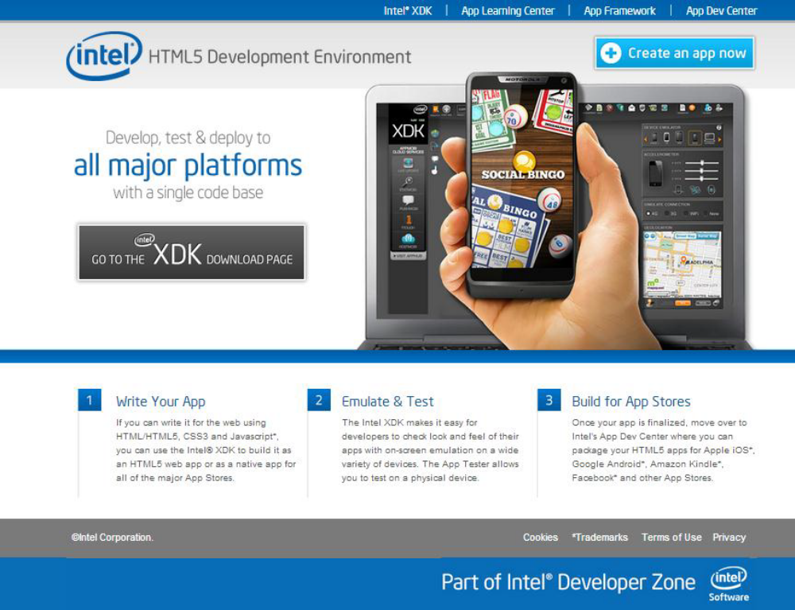
Click on the Create an app now button to start a new HTML5 app project.
The next dialog that appears is used to start a new HTML5 app project. The first step is to give


your project a name. For the time being, just name the app “myfirstproject”.

Leave the radio button on the first entry entitled “Use the App Starter wizard…” selected. App Starter is a tool for creating a simple, clean, and effective starting app. It relies on App Framework, a lightweight and fast JavaScript library for mobile HTML5 app development. Click Next to continue into App Starter. Use the App Starter wizard to create the navigation and page structure for a sample application. Take a look at the screen shot samples below for refere

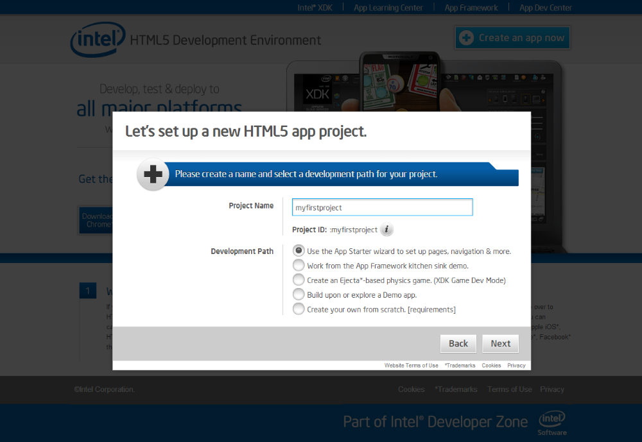

After the installation of Intel XDK IoT from the intel’s website, you will be able to signup for the intels. After successful registration you can view the intels gallarey of projects.
Now that our project automatically logs data concerning the energy consumption on Google Docs, it's time to go back to the relay control. For now, we tested the relay by going into a web browser and typing the correct REST function with the name of the pin we want to change. However, that's not very convenient. You don't want to type something in your web browser every time you want to turn a light on in your home. What we would like to have instead is a nice graphical interface with buttons that can be pressed to turn a light on or off. It would be even better if this interface could be accessed not only from a web browser on your computer but also from any smartphone or tablet in your home. That's exactly what we are going to build now.
DEVELOP

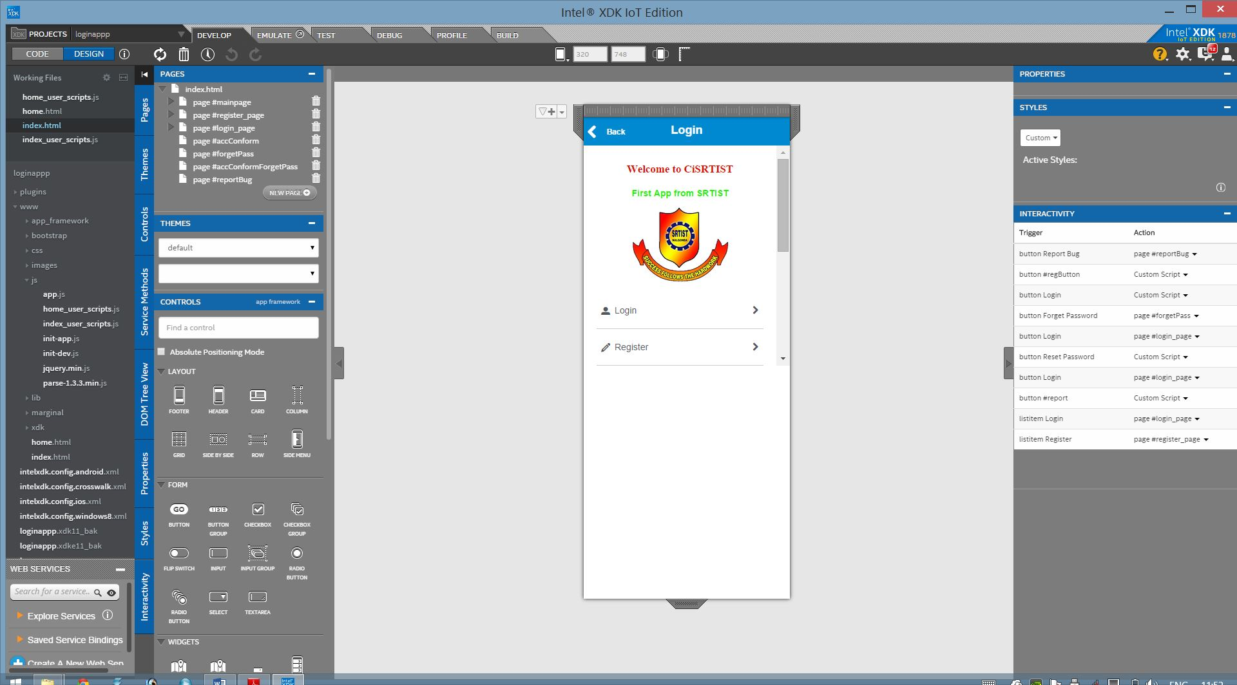

Here we can develop the created project. One have two options to develop, DESIGN view and CODE view.
In DESIGN view we can drag and drop all the controls, service methods, triggers and other controls can also be established without knowing code knowledge.
EMULATE

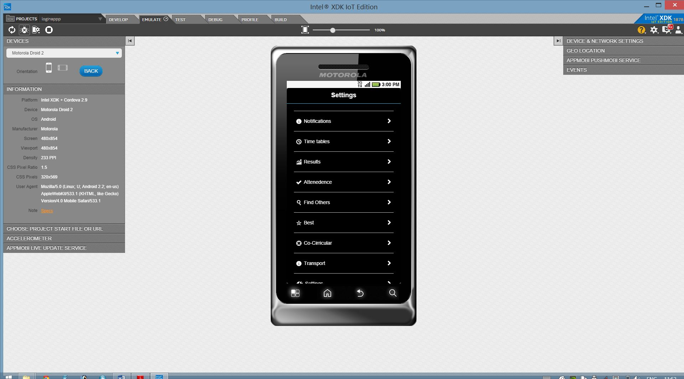

TEST

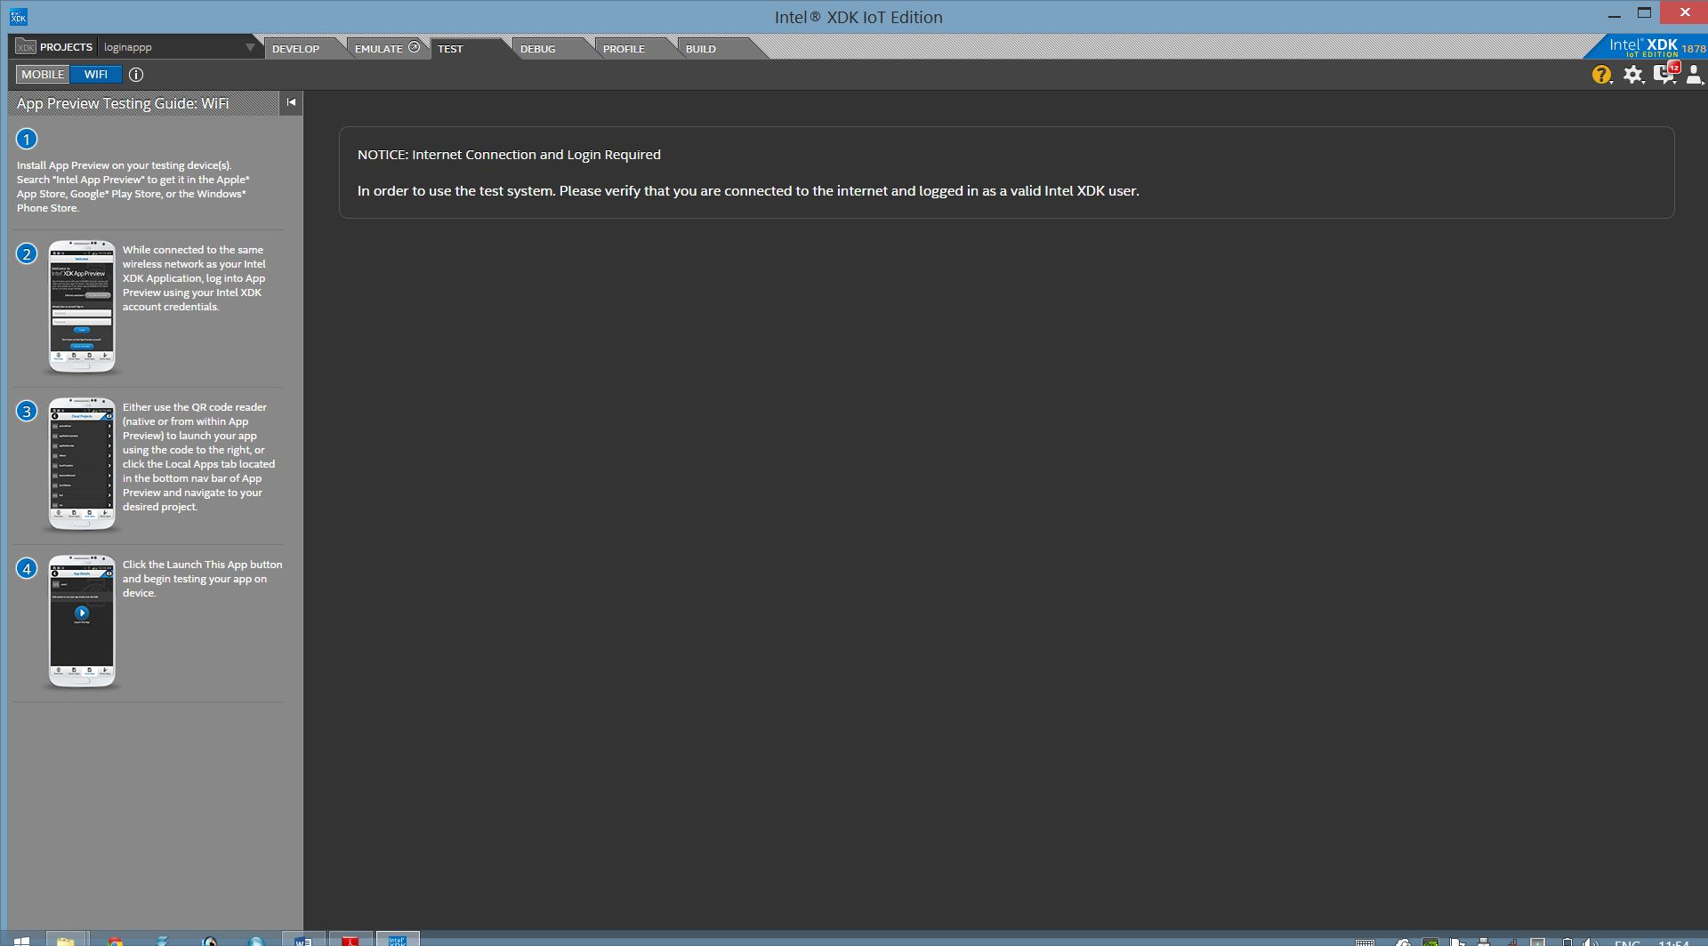
DEBUG

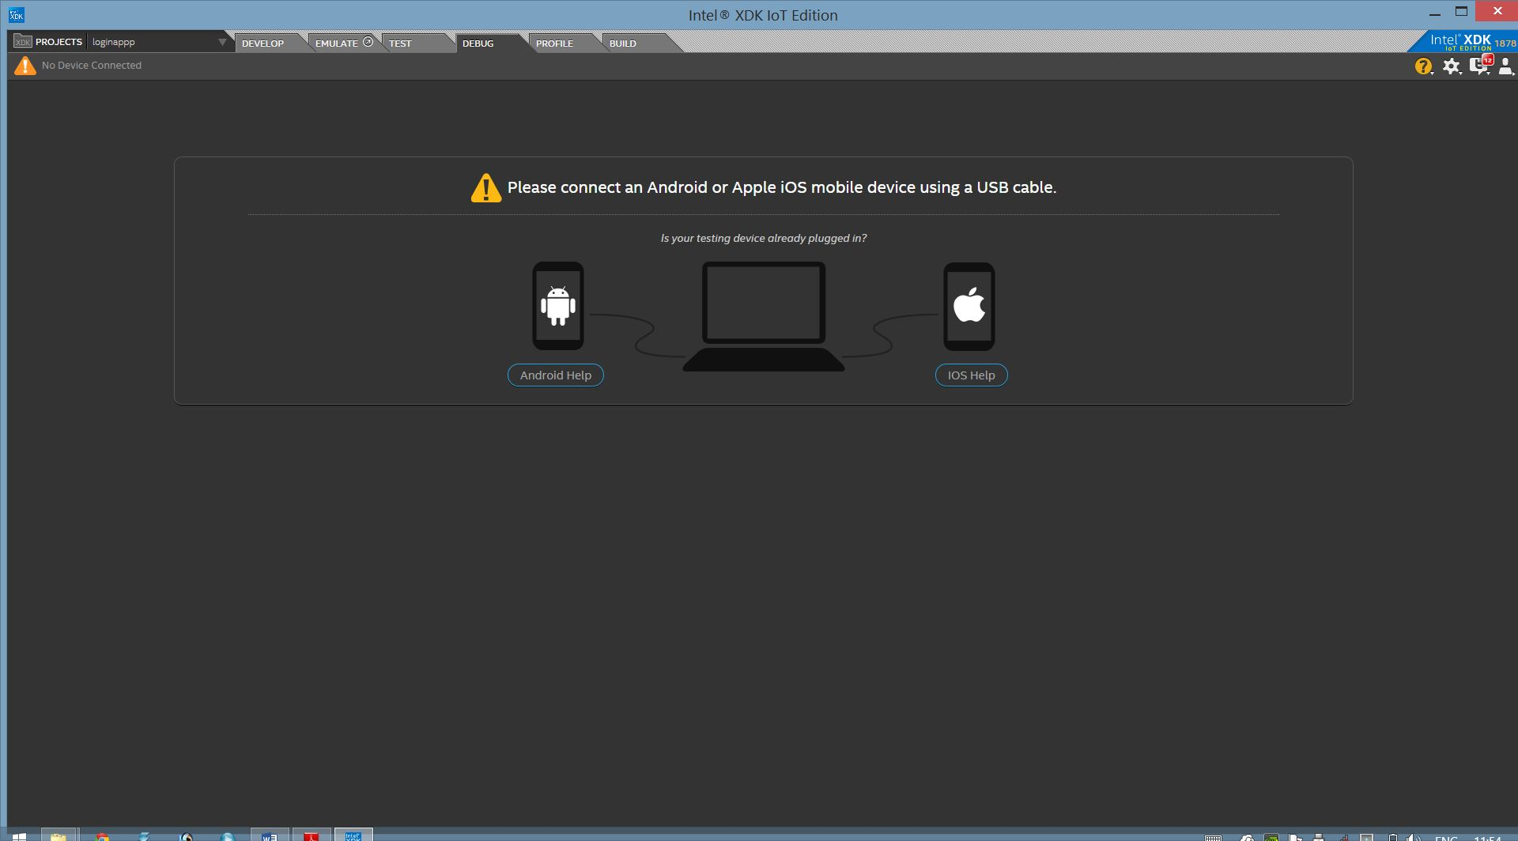

PROFILE
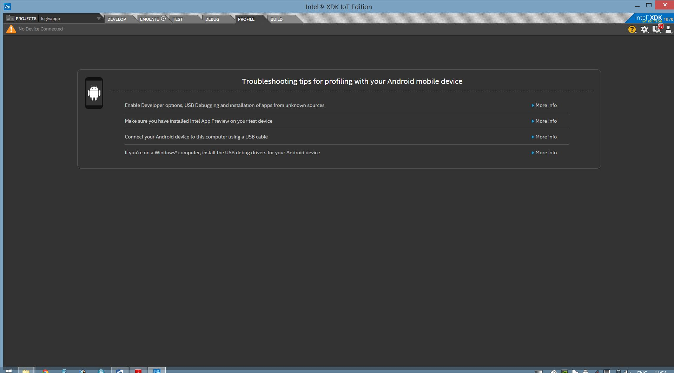
BUILD
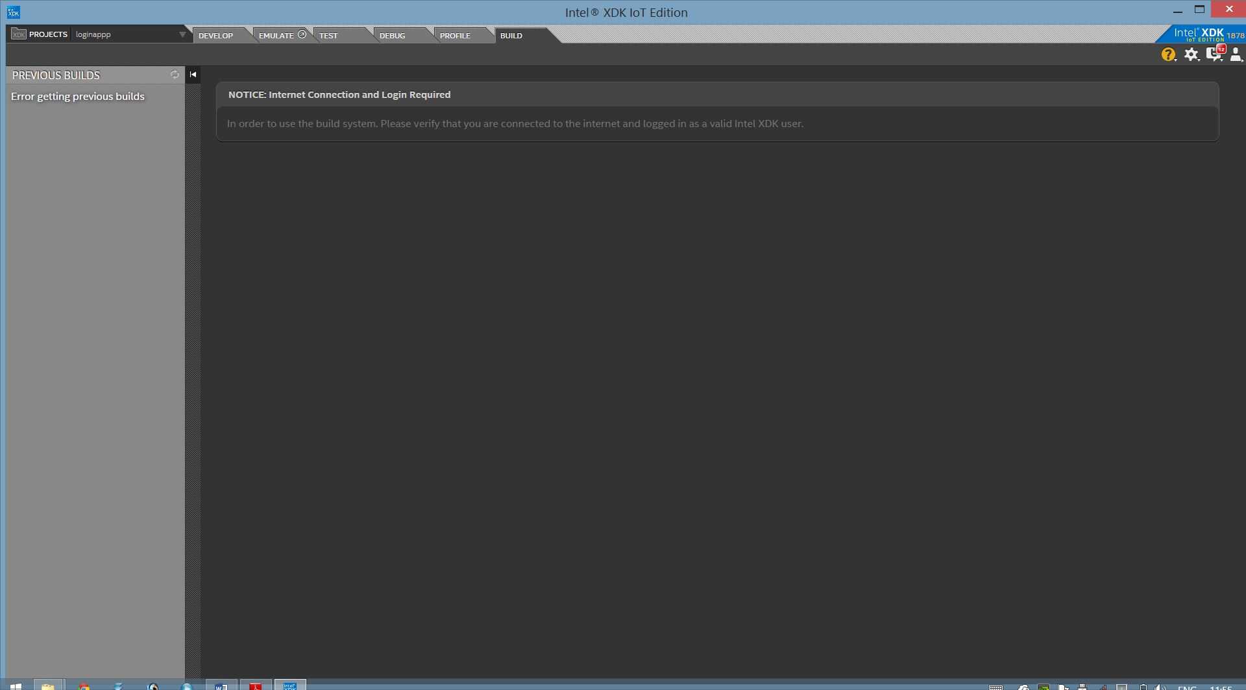
CONCLUSION
REFERENCES

- http://en.wikipedia.org/wiki/HTML5
- http://en.wikipedia.org/wiki/HTML#HTML_version_timeline
- http://www.yourhtmlsource.com/starthere/historyofhtml.html/
- http://www.html5arena.com/blog/html5/10-major-advantages-of-html5/
- http://www.w3schools.com/html5/html5_new_elements.asp

